Stock Price Prediction Using LSTM (Long Short-Term Memory)
Disclaimer: Don’t Use it for actual stock market investment. It’s just a model that helps to understand the stock more deeply

Stock Market: A place where people used to buy and sell shares of companies
Why to use prediction in stock market?
Because sometimes, investor need to understand the trend of the particular companies whether that goes from profit or loss.
It helps investor to buy, sell and hold the stock

This model is just a demo. We can’t predict the accurate trends. But we can analyse the trend more carefully, and that can also helps the investor in some way
Model Used: LSTM (Long Short Term Memory)
LSTM is a special type of Neural Network that used in time series data because it can understand sequences of data (I mean for stock market we need to understand the trend. In LSTM, we can remember the past few-days trend and based on that it make prediction)

Code explanation:
Data Importing
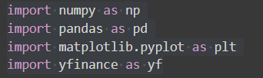
These are libraries I have used to accomplished this project
-Numpy for numerical Computation
-Pandas for data manipulation and reading the file
-matplotlib for data visualisation
-yfinance known as Yahoo Finance is used for getting the real time stock market data

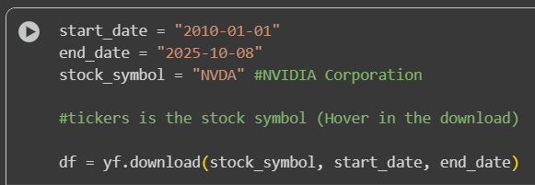
Here I am choosing to predict NVDIA’s stock market. And the stock symbol is “NVDA”. (Every company have it’s own stock symbol)

Data Preprocessing
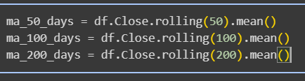
Another main part, here I set 3 variables. Those are moving averages of certain time- 50,100,200 days.
Moving average is a way to calculate the average for a certain day. (In this case, 50,100, 200). It helps investor to understand the trend whether it is going upward or downward.

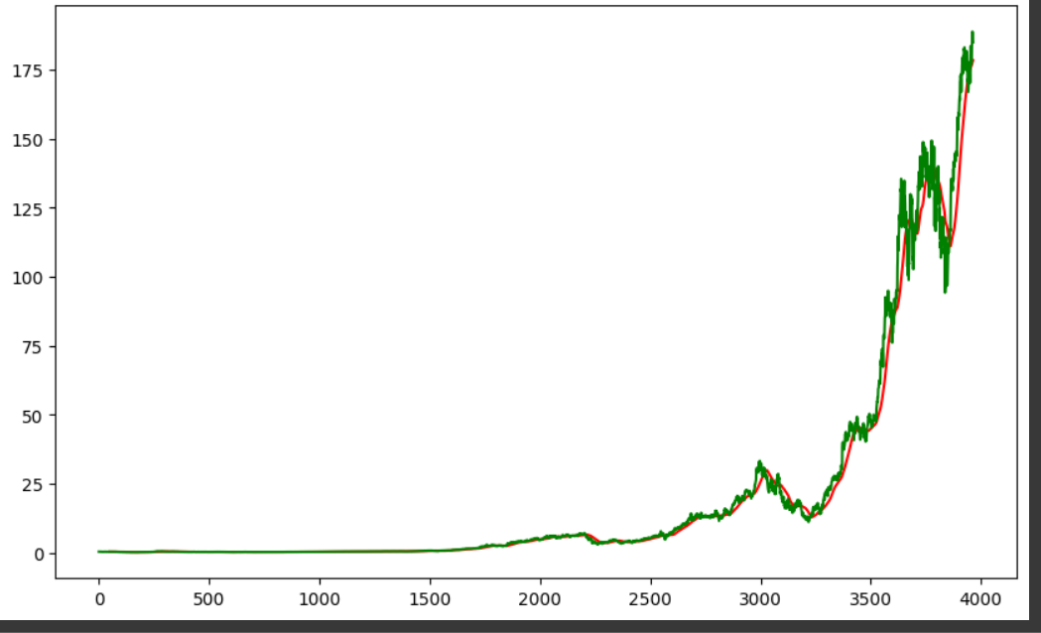
It is 50 days moving average
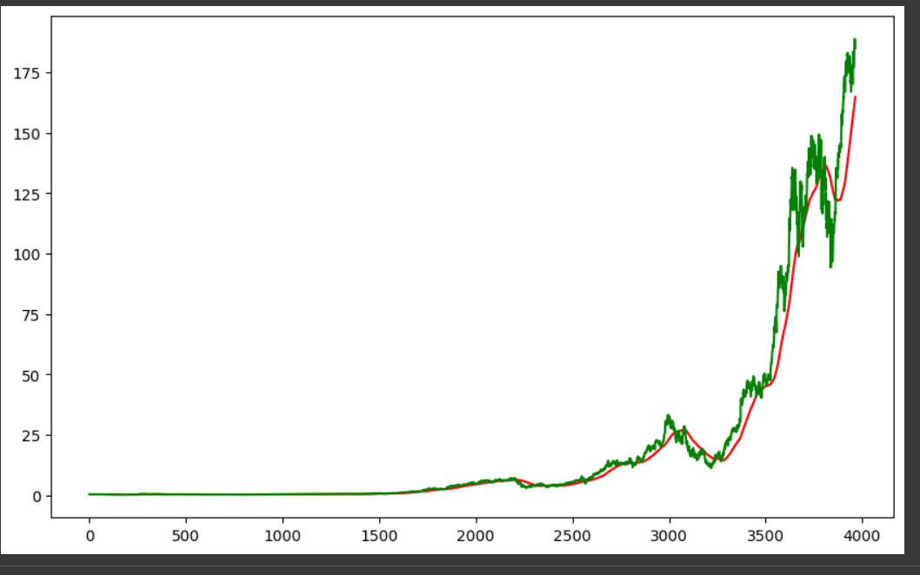
It is 100 days MA
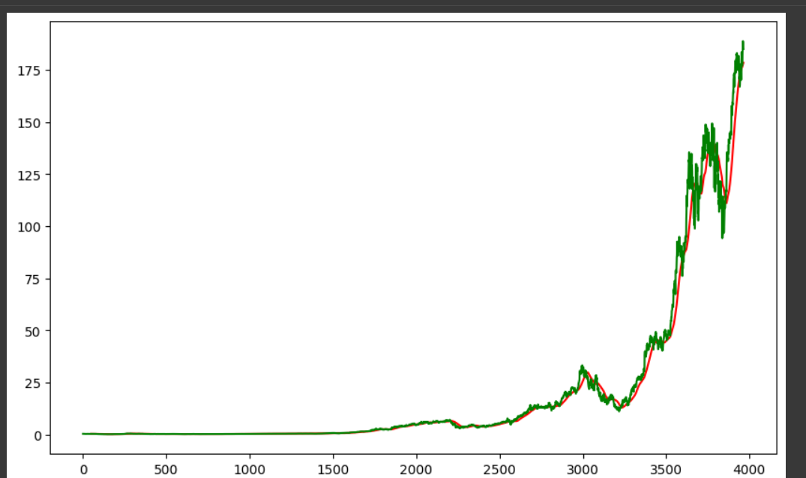
It is 200 days MA

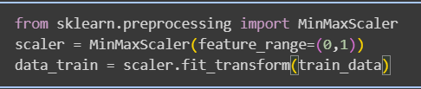
Min Max Scaler actually helps to reduce the large data into small ranges (In this case- 0 and 1). And it makes our model to predict more faster and more accurately make the predictions.

→ Stock market prices can go so much higher so we need min max scaler

Why I am choosing 0 and 1?
Simple, Because LSTM or any neural network can work better with smaller value and make the prediction more fast and accurately.

Model Making
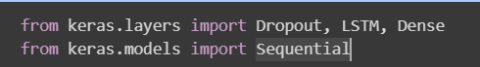
For making the model, I am using Keras.
Keras is a python library that used for building deep learning model.
It is better than Tensorflow because Keras engine performs heavy calculations

Dense – Fully connected Neural Network
Dropout – Some time large data can cause overfitting. Dropout helps to prevent that. It simply turns off some neurons during training process.

And the model structure is “Sequential” means layer by layer

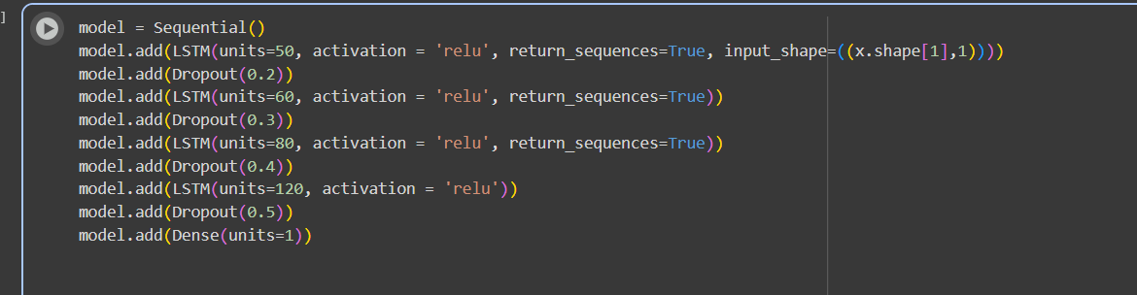
Units is actually I am declaring how much neuron will be in First layer. And as
Activation function: “Relu”
And tell the model to ignore 20% neurons for prevent the overfitting

First Layer:
Neurons: 50 Activation Function: Relu Dropout: 20% neurone

Second Layer:
Neurons: 60 Activation Function: Relu Dropout: 30% neurone

Third Layer:
Neurons: 80 Activation Function: Relu Dropout: 40% neurone

Fourth Layer:
Neurons: 120 Activation Function: Relu Dropout: 50% neurone

Then I put dense(unit=1). To connect the all neurons. So that the output is only One

**There is problem that occurs in time series data. That is vanishing gradient (sometime gradients dropped and become so small and backpropagated caused weights to updated more slowly). To prevent this problem we used Relu. Because Relu checks whether the value is positive or negative. If positive then the value otherwise 0
But in Sigmoid it’s range between = 0 and 1
Tanh = -1 to 1
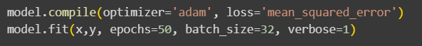

Adam is used because it is fast.
Predicting the data
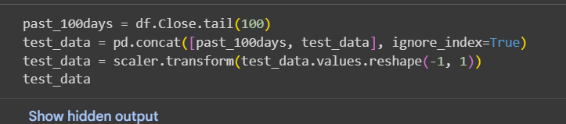
Predicting the stock prices by checking the past 100 days trend

And plot the figure
